**Single direction, grid and spatial multi-scroll attractors in Hopfield neural network with the variable number memristive self-connected synapses**

Qiuzhen Wan a, *, Qiao Yang a, Tieqiao Liu b, Chaoyue Chen a, Kun Shen a

a College of Information Science and Engineering, Hunan Normal University, Changsha 410081, P. R. China

b School of Information, Zhejiang University of Finance and Economics Dongfang College, Haining 314408, P. R. China

**Abstract:** Due to the synapse-like nonlinearity and memory characteristics, the memristor is often used to simulate the biological neural synapse. In this paper, a family of three-neuron Hopfield neural network (HNN) models based on the variable numbermemristive self-connected synapses is proposed. Firstly, a single memristive self-connected synapse (SMSCS) HNN model is constructed, which can generate a single direction multi-scroll attractor controlled by the memristor parameters. Meanwhile, its dynamic behaviors including equilibrium points, multiple coexisting attractors and controllable *n*-scroll chaotic attractors are analyzed. Secondly, based on the above SMSCS HNN model, two types of multiple memristive self-connected synapse (MMSCS) HNN models are constructed. By changing the control parameters of the memristors, these MMSCS HNN models can not only generate the different scroll numbers of grid and spatial multi-scroll attractors, but also can produce the spatial initial-offset coexisting attractors. The above three HNN models utilizing the variable number memristors to simulate one to three self-connected synapses can generate a class of complex chaotic attractors, which include single direction, grid and spatial multi-scroll attractors. Finally, the feasibility of the proposed HNN models is verified by the FPGA platform.

**Keywords:** Hopfield neural network, single direction multi-scroll attractor, grid multi-scroll attractor, spatial multi-scroll attractor, memristive self-connected synapse, FPGA implementation.

*Corresponding author. E-mail address: wanqiuzhen@sina.com (Qiuzhen Wan)

**1. Introduction**

The biological brain, which is composed of a large number of neurons and synapses, is a highly complex nonlinear system with the chaotic dynamic behaviors [1, 2]. We use the brain for thinking, associating, memorizing, and reasoning and more [3]. Nowadays, artificial neural networks have received much attention for their design to imitate the structure of the biological brain [4-6]. It is known that a large number of neuron models and neural network models have been proposed so far, such as Hodgkin-Huxley (HH) neuron [7], Hindmarsh-Rose (HR) neuron [8], deep neural network [9] and convolutional neural network [10], and so on. Among these models, the Hopfield neural network (HNN) has become an important model for studying the biological brain characteristics due to its brain-like network structure and the complex dynamic characteristics [11].

Memristor, as the fourth basic electronic element after resistor, capacitor and inductor, is defined by Chua for describing the relationship between charge and magnetic flux [12]. In the last twenty years, due to its intrinsic nonlinear characteristics, the memristor has been widely applied to construct memristive chaotic systems to obtain complex dynamic behaviors [13-15], such as chaos, hyperchaos, bursting, coexistent bifurcation, etc. In recent years, due to its plasticity and nonvolatility closely related to the memory characteristic of neurons, the memristor is widely employed in the neural networks. On the one hand, the memristor is one of the most suitable components for simulating the strengthening or weakening of synaptic weights. The memristor can be utilized to achieve the changeable connection weight by replacing the resistive connection weight. Numerous memristive neural network (MNN) models based on these strategies have been proposed to exhibit a variety of complex dynamical behaviors [16, 17]. For instance, Bao *et al*. [16] proposed a hyperbolic-type memristor based three-neuron HNN to reveal the coexistence of asymmetric attractors, which is achieved through substituting one of resistive coupling-connection weight with a memristive synaptic weight. On the other hand, the memristor has the electrical properties of magnetic flux, which can be used to simulate the neural response to external stimuli, such as electromagnetic radiation or electromagnetic induction current. Many researchers have used the memristors to simulate the effects of electromagnetic radiation on artificial neural networks [18-20]. For instance, Hu *et al*. [21] firstly studied a small HNN with three neurons, in which one of the three neurons is exposed to electromagnetic radiation, and the system can appear chaotic motion and periodic motion intermittently. Lin *et al*. [22] found that with the increase of the number of neurons stimulated by electromagnetic radiation, the dynamical behaviors of the HNN will gradually change from period moving to chaos, transient chaos and intricate hyperchaos. More recently, by using a discrete memristor to simulate electromagnetic radiation, Lai *et al.* [23] constructed a discrete neural network which can observe the phenomenon of homogeneous and heterogeneous infinite coexistence attractors. In addition, the electromagnetic induction current induced by the membrane potential difference between neurons in the neural network can also be simulated by memristors to build different MNNs. For instance, Chen *et al.* [24] employed the hyperbolic-type memristor to describe the potential difference between the interconnected neurons, and presented a unified memristive HNN model to simulate the dynamic behavior of electromagnetic induction current. In Reference [25], by introducing a memristor-based electromagnetic induction current to substitute the externally applied current in a Morris-Lecar model, the presented system shows the diverse period-adding bifurcations as well as abundant periodic and chaotic burst firings. When considering both electromagnetic radiation and electromagnetic induction current, for example, Wan *et al.* [26] used a quadratic nonlinear memristor and a hyperbolic-type memristor to simulate the influence of electromagnetic radiation and electromagnetic induction current on a simple HNN, and found the coexistence bifurcation phenomena and the coexistence attractors. In short, the versatility of memristors has made them a fascinating topic in neural networks.

Chaotic attractors can be categorized into single-scroll, double-scroll and multi-scroll attractors based on their scroll number. Due to their intricate topological structure and rich ergodic space, the multi-scroll attractors have the potential applications in engineering areas, such as pseudo-random number generator [27], medical image encryption and remote sensing image encryption [28, 29], which make them more secure and efficient compared to the single-scroll or double-scroll attractors. In the past few years, the multi-scroll attractors are widely studied in the traditional chaotic systems, such as introducing trigonometric functions [30] or symbolic functions [31], employing fractal methods [32, 33], etc. However, the above common methods in the traditional chaotic systems [30-33] can’t be used to construct multi-scroll attractors in the neural networks, since these methods can’t be biologically explained. At present, only a few papers mentioned the generation of multi-scroll attractors in the neural networks. For example, Zhang *et al*. [34] constructed a non-equilibrium memristive HR neuron, which can generate the multi-scroll hidden attractors with complex topology by changing the internal parameters of memristor. Yu *et al*. [35] proposed a memristive HNN and constructed a novel local active memeristor to simulate the synapse connection weight, which can perform the controllable multi-double-scroll chaotic attractors and controllable initial offset boosting coexistence. Additionally, Wan *et al*. [36] designed a memristive HNN under external pulse controlled memristor, pulse current stimulation and their combined effects, which can generate the various multi-scroll chaotic and multi-scroll periodic strange attractors with symmetric structure. In another study, Lai *et al*. [37] introduced the different number of multi-piecewise hyperbolic function into the HNN model, which results in the successful expansion of grid multi-scroll attractors in the different directions. Wan *et al.* [38] proposed a new method to generate the grid multi-scroll attractors in an HNN by integrating the multi-level-logic pulse current and the multi-piecewise memristor into an HNN model. However, most of the above studies have focused on the single direction multi-scroll attractors, and the study of the grid and spatial multi-scroll attractors with higher complexities in the neural networks remains relatively limited. Therefore, the study of the multi-direction expansion of multi-scroll neural networks with the different working mechanism still needs further exploration.

Motivated by the above mentioned considerations, based on a three-neuron HNN, this paper study the dynamic behavior of single direction, grid and spatial multi-scroll attractors in three different cases which utilizing the multi-piecewise memristors to simulate one to three self-connected synapses. The main contributions and characteristics of this paper can be summarized as follows.

1) Firstly, by introducing a multi-piecewise memristor, a new three-neuron HNN model based on a single memristive self-connected synapse (SMSCS) is constructed. The SMSCS HNN model can generate a single direction multi-scroll chaotic attractor controlled by the memristor parameters. The phase diagram, bifurcation diagram and Lyapunov exponent are used to analyze the complex dynamic behaviors, including equilibrium points, multiple coexisting attractors and controllable *n*-scroll chaotic attractors.

2) Secondly, two types of multiple memristive self-connected synapse (MMSCS) HNN models are constructed. These MMSCS HNN models are implemented on the basis of SMSCS HNN model by adding one or two memristive self-connected synapses, respectively. By changing the control parameters of the memristors, these MMSCS HNN models can not only generate the different scroll numbers of grid and spatial multi-scroll attractors, but also can produce the spatial initial-offset coexisting attractors.

3) Finally, the single direction, grid and spatial multi-scroll attractors along with the spatial initial-offset coexisting attractors are implemented on the FPGA platform, verifying the feasibility of the proposed SMSCS and MMSCS HNN models.

The rest of this paper is arranged as follows. Section 2 introduces the mathematical model of SMSCS HNN and analyzes its complex dynamical characteristics through the numerical methods. Section 3 introduces two types of MMSCS HNNs, focusing on the discussion of grid and spatial multi-scroll attractors along with the spatial initial-offset coexisting behaviors. Section 4 discusses the experimental results with the FPGA platform to verify the numerical results. Section 5 summarizes with a few conclusions.

**2. The Hopfield neural network with the single memristive self-connected synapse**

In this section, we first propose a three-neuron HNN based on the SMSCS to generate the single direction multi-scroll attractors. Meanwhile, its dynamic behaviors including equilibrium points and their stability, multiple coexisting attractors and controllable *n*-scroll chaotic attractors are analyzed in detail.

**2.1. The mathematical model**

Hopfield neural network is a powerful artificial neural network with a complex brain-like network structure. The original HNN containing *n* neurons can be mathematically described by a set of differential equations as follows

 (1)

In equation (1), *Ci* refers to the membrane capacitance of the *i*-th neuron, *xi* is its membrane voltage, *Ri* is its membrane resistance, and *Ii* is the input bias current. In order to simplify the calculation, the values of parameters *Ci*, *Ri* and *Ii* are set to 1, 1 and 0 respectively. In addition, tanh(*xj*) is a neuronal activation function. *wij* represents the synaptic weight between the neuron *i* and the neuron *j*, which directly affects the performance and storage capacity of neural network. In order to achieve a better performance, a new three-neuron HNN is constructed by selecting the appropriate *wij* as synaptic weights according to equation (1) through the trial-and-error method [39], whose mathematical expression is

 (2)

Where *x*, *y* and *z* are the membrane potential of neuron *i* (*i*=1, 2, 3), respectively.



Fig. 1. The connected topology of the HNN with the single memristive self-connected synapse.

Memristor is a kind of controllable nonlinear memory device which is often used to simulate the biological neural synapse. Constructing a memristive neural network requires replacing the resistive synaptic weights with the memristive synaptic weights. In this paper, a multi-piecewise memristor model [40] is introduced as follows

 (3)

Where *a, b, d* and *e* are the four parameters of the memristor, and *W*(*φ*) is the memductance of the memristor model. *h*(*φ*) is the internal state variable function, which is divided into two parts as follows

 (4)

In equation (4), *G*, *M* and *N* are the three parameters of the function *h*(*φ*). Here, *G* is a fixed coefficient with a value of 0.45. It is important to note that *N* and *M* are the adjustable parameters of the memristor. By adjusting the values of *N* or *M*, it is possible to generate the odd or even number of chaotic attractors, thereby forming the multi-scroll attractors, so it has the higher level of adjustability and diversity compared to the other memristor models.

According to this method, a multi-piecewise memristor of equation (3) is introduced to simulate the self-connected synapse of neuron 2. By transforming the resistive synaptic weight into a memristive synaptic weight, the SMSCS HNN is constructed to achieve the single direction multi-scroll attractors. The SMSCS HNN topology is depicted in Fig. 1, and its mathematical model can be described as follows

 (5)

Where *φ*1 represents the internal state of memristor, *W*1 is represented as *a*+*bφ*1, and *d*1 and *e*1 are the memristive synapse parameters. The values of the control parameters *M* or *N* in the function *h*(*φ*1) determine that the SMSCS HNN defined by equation (5) can generate the different scroll numbers of multi-scroll attractors.

**2.2. Equilibrium points and their stability**

The equilibrium points and their stability analysis of the SMSCS HNN can help to better understand the brain function and develop the new neuromorphic systems [41]. As an example, we first fix the parameter *N*=2 in the function *h*(*φ*1), then set the left side of equation (5) to zero, and the equilibrium points can be obtained by solving the following equation

 (6)

Obviously, equation (6) with such a complex structure is difficult to be solved by the ordinary methods. Therefore, in order to obtain its numerical solution, the above equation is first expressed by two implicit functions *f*1(*z*, *φ*1)and *f*2(*z*, *φ*1), as follows

 (7)



(a) (b)

Fig. 2. *h*(*φ*1) at *N*=2, (a) fifteen equilibrium points represented by the intersection of *f*1(*z*, *φ*1) and *f*2(*z*, *φ*1), (b) five double-scroll attractors with fifteen equilibrium points.

Here, the parameters are selected as *c*1=-0.0002, *a*=1, *b*=-0.001, *d*1=1.1, *e*1=1.62, and the initial state is set as (*x*0, *y*0, *z*0, *φ*10) = (-1, 0.1, 0.1, 0.1). To obtain the solution, the graph analysis method is used to draw the curve of the two implicit functions, and the value is determined by the intersection of the green curve *f*1(*z*, *φ*1) and the red curve *f*2(*z*, *φ*1), as shown in Fig. 2(a). The two curves have a total of fifteen intersection points, that is, a total of fifteen equilibrium points. It is not difficult to find that these fifteen equilibrium points are extended to both sides based on the middle three equilibrium points [(-0.234, -0.538), (0, 0), (0.234, 0.538)]. This is because the control parameter *M* or *N* value of the function *h*(*φ*1) inside the memristor determines the number of equilibrium points. As shown in Fig. 2(b), the phase diagram between the equilibrium points and the single direction multi-scroll attractors means that the introduction of the multi-piecewise memristor leads to the expansion of the double-scroll attractors in the direction of *φ*1. The eigenvalues of the equilibrium points are calculated using the Jacobi matrix *J*, which is shown as follows

 (8)

The eigenvalues calculated through MATLAB indicate that all equilibrium points of the system are unstable saddle points. This includes two different types of equilibrium points: unstable index-1 saddle points and unstable index-2 saddle points. According to the Shil’nikov theorem [42], it is shown that the SMSCS HNN can generate the self-excited chaotic attractors.

**2.3. Multiple coexisting attractors**

In this subsection, taking *N*=0 as an example, with parameters *a*=1, *b*=-0.001, *d*1=1.1, *e*1=1.62, and the coupling strength *c*1 in the range [-0.3, 0.3] as a tunable parameter, the initial states (*x*0, *y*0, *z*0, *φ*10) are marked with the red trajectory at (-1, 0.1, 0.1, 0.1) and the blue trajectory at (1, 0.1, 0.1, 0.1) respectively. The coexisting bifurcation diagram is illustrated as shown in Fig. 3(a). As the parameter *c*1 increased, the SMSCS HNN exhibits the complex bifurcation behaviors including periodic, quasiperiodic and chaotic behaviors. Upon a careful observation, it is noted that at *c*1=-0.1992, a period-doubling bifurcation occurs, transitioning from the original period-1 attractor to a period-2 attractor; at *c*1=-0.157, the system transitions from a period-2 attractor to a period-4 attractor. When *c*1=-0.138, the system no longer exhibits the periodic behavior. Instead, the chaotic dynamics occur within two discontinuous intervals [-0.138, 0.0147] and [0.024, 0.183]. Furthermore, the bifurcation diagrams of two different initial states overlap when *c*1>-0.138, indicating the complex dynamical behavior of the system.

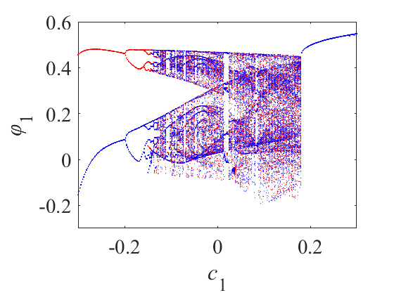 

(a) (b)

Fig. 3. Dynamical behaviors related to the parameter *c*1 when *N*=0, (a) bifurcation diagram, (b) Lyapunov exponents.

At the same time, with the same parameters but considering only the initial state (-1, 0.1, 0.1, 0.1), the corresponding Lyapunov exponents are plotted in Fig. 3(b). Through observation, it was noted that the system’s Lyapunov exponents become positive when the coupling parameter *c*1 falls within the discontinuous intervals [-0.138, 0.0147] and [0.024, 0.183], while the maximum Lyapunov exponents in other intervals remain at 0. This implies that the chaotic attractors occur when *c*1 is within these two intervals, while the periodic or quasiperiodic attractors are generated in the other intervals. This observation corroborates the information revealed by the bifurcation diagram, further elucidating the system’s dynamical behavior and chaotic characteristics. For example, the phase portraits for the two initial states (-1, 0.1, 0.1, 0.1) and (1, 0.1, 0.1, 0.1) are plotted under the different parameters *c*1, also distinguished by the blue and red curves. As shown in Fig. 4, there illustrate some typical symmetric coexisting attractors, including coexisting limit cycles, coexisting period-2 attractors, coexisting period-4 attractors and coexisting chaotic attractors. It also corroborates the phenomenon of overlapping bifurcation diagrams for the two different initial states after *c*1>-0.138.



(a) (b)



(c) (d)

Fig. 4. Coexisting attractors with the different parameters *c*1, (a) coexisting limit cycles at *c*1=-0.2; (b) coexisting period-2 attractors at *c*1=-0.18; (c) coexisting period-4 attractors at *c*1=-0.15; (d) coexisting chaotic attractors at *c*1=-0.0002.

**2.4. Controllable *n*-scroll chaotic attractors**

Numerical simulations show that the SMSCS HNN can generate any number of multi-scroll attractors along the *φ*1 direction. By setting parameters *a*=1, *b*=-0.001, *c*1=-0.0002, *d*1=1.1, *e*1=1.62, and taking the initial state as (-1, 0.1, 0.1, 0.1), *n*-scroll chaotic attractors as shown in Fig. 5. The number of scrolls generated by SMSCS HNN is controlled by selecting the different values of *N* or *M* in equation (4), which are 2*N*+1 and 2*M*+2. To further reveal the complex chaotic dynamics, Fig. 6 presents the bifurcation diagrams of multi-scroll attractors characterized by a dense patch of points with respect to the parameter *c*1. As shown in Fig. 6, the size of the bar-shaped region continually increases as the values of *M* or *N* change, further proving that the system has the ability to generate the controllable single direction multi-scroll chaotic attractors.



(a) (b) (c)



(d) (e) (f)

Fig. 5. Single direction multi-scroll attractors in the *φ*1-*y* plane with the different values of *N* and *M*, (a) *N*=0; (b) *M*=0; (c) *N*=1; (d) *M*=1; (e) *N*=2; (f) *M*=2.

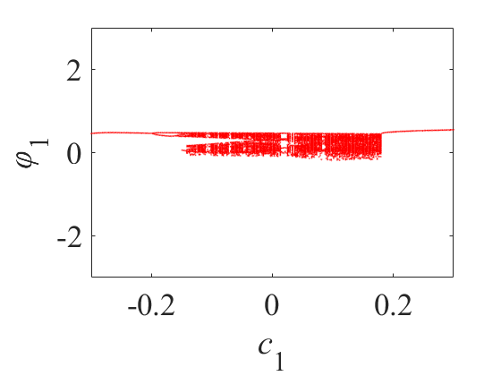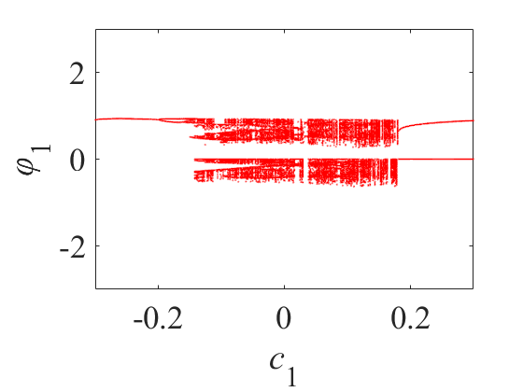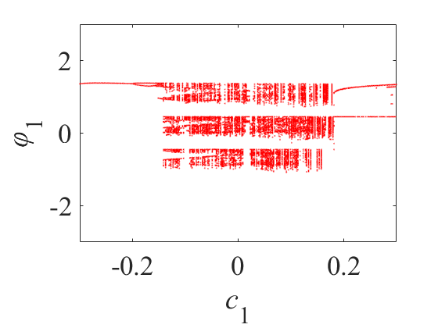

(a) (b) (c)

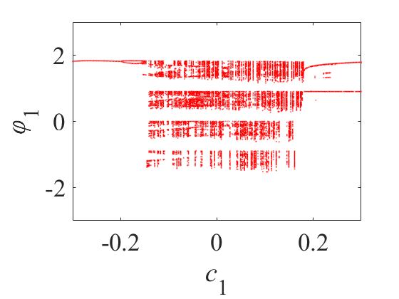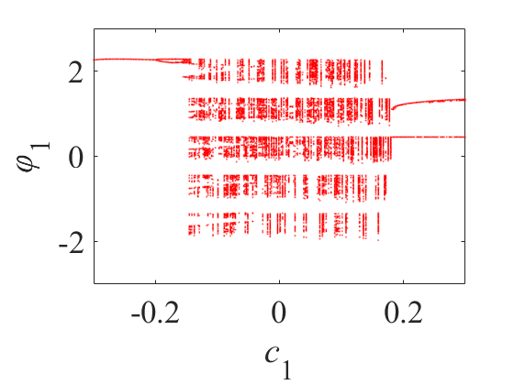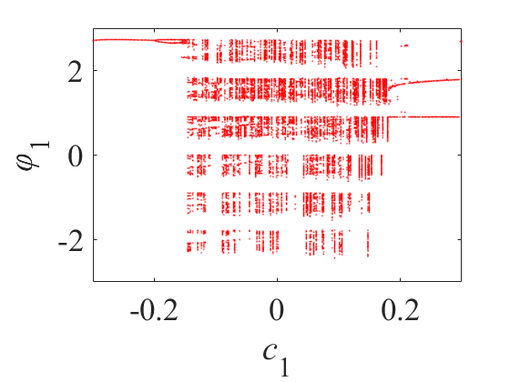

(d) (e) (f)

Fig. 6. Bifurcation diagrams with the different values of *N* and *M*, (a) *N*=0; (b) *M*=0; (c) *N*=1; (d) *M*=1; (e) *N*=2; (f) *M*=2.

**3. The Hopfield neural network with the multiple memristive self-connected synapses**

Based on the SMSCS HNN model, in this section, two new MMSCS HNNs are constructed which again introduces the multi-piecewise memristors to simulate the other self-connected synapses. Through this improvement, it can generate the grid and spatial multi-scroll attractors along with the spatial initial-offset coexisting attractors. Compared to the single-direction multi-scroll attractors, the generated grid and spatial multi-scroll attractors have a higher adjustability and complexity, thus holding the greater research significance.

**3.1. Grid multi-scroll chaotic attractor**

Building upon the network topology structure shown in Fig. 1, we introduce an identical multi-piecewise memristor of equation (3) as the other self-connected synapse of neuron 3 to achieve the extension of multi-scroll attractors in two directions, resulting in the generation of grid multi-scroll chaotic attractors. The network topology of the double memristive self-connected synapses HNN is depicted in Fig. 7.



Fig. 7. The new HNN model with the double memristive self-connected synapses.

The mathematical model can be described as follows

 (9)

The parameters are set as follows: *a*=1, *b*=-0.001, *c*1=-0.0002, *d*1=1.1, *e*1=1.62, *c*2=4, *d*2=1.1, *e*2=1.62. Meanwhile, *W*2=*a*+*bφ*2 and *φ*2 represents the internal state of the newly introduced memristor. The chosen initial state is (*x*0, *y*0, *z*0, *φ*10, *φ*20) = (-1.2, 0.1, 0.1, 0.1, 0.2). Here, the extension of the double-scroll attractor is achieved by controlling the adjustable parameters *N* or *M*. To obtain the grid multi-scroll attractors which need to be implemented in the *φ*1-*φ*2 plane, the two sets of adjustable parameters *Mi*/*Ni* (*i*=1, 2) are required to be adjusted appropriately at the same time. By selecting the different control parameters, it generates some typical grid multi-scroll chaotic attractors as shown in Fig. 8. Numerical simulations reveal that by varying the control parameters, the grid multi-scroll attractors in the form of [(2*N*1+1) or (2*M*1+2)] × [(2*N*2+1) or (2*M*2+2)] can be obtained. Clearly, the proposed double memristive HNN model can generate any number of the grid multi-scroll attractors.



(a) (b) (c)

Fig. 8. Grid multi-scroll chaotic attractors in the *φ*1-*φ*2 plane with the different values of *N*1/*M*1 and *N*2/*M*2, (a) 2×2-double-scroll attractor (*M*1=0, *M*2=0), (b) 3×3-double-scroll attractor (*N*1=1, *N*2=1), (c) 4×4-double-scroll attractor (*M*1=1, *M*2=1).



(a) (b)

Fig. 9. *h*(*φ*1) and *h*(*φ*2) at *N*1=*N*2=1, (a) equilibrium points on the *φ*1-*φ*2 plane, (b) equilibrium points on the *φ*1-*φ*2 plane along with the phase portrait.

Meanwhile, the graph analysis method is still used to determine the equilibrium points. Taking *N*1=*N*2=1 as an example, the distribution of equilibrium points on the *φ*1-*φ*2 plane is shown in Fig. 9(a). Through further research, it has been determined that the number of equilibrium points is three times the number of single direction multi-scroll attractors, which is equal to 3×[(2*N*1+1) or (2*M*1+2)]×[(2*N*2+1) or (2*M*2+2)]. Fig. 9(b) shows the relationship between the equilibrium points and the phase diagram of the grid multi-double-scroll attractors.

**3.2. Spatial multi-scroll chaotic attractor**



Fig. 10. The new HNN model with the triple memristive self-connected synapses.

To achieve the spatial multi-scroll attractor, based on the network topology shown in Fig. 7, the resistive self-connected synapse of neuron 1 is replaced by a memristive self-connected synapse, where the memristor is selected as equation (3) and its internal state is denoted as *φ*3. Consequently, the network topology of the triple memristive self-connected synapses HNN is shown in Fig. 10. The triple memristive HNN based on three neurons is represented by a mathematical model as follows

 (10)

Where *W*3=*a*+*bφ*3, and choosing the initial state (*x*0, *y*0, *z*0, *φ*10, *φ*20, *φ*30) = (-1.2, 0.1, 0.1, 0.1, 0.2, -1), the setting parameters are as follows: *a*=1, *b*=-0.001, *c*1=-0.0002, *c*2=4, *c*3=-1.4, *d*1=1.1, *e*1=1.62, *d*2=1.04, *e*2=1.71, *d*3=1.2, *e*3=2.62. We adjust the controllable parameters *Mi* or *Ni* (*i*=1, 2, 3) of the three memristors to achieve the expansion of multi-scroll attractors in the *φ*1-*φ*2-*φ*3 three directions, thereby generating the spatial multi-scroll chaotic attractors. By selecting the different adjustable parameters, it can generate some typical spatial multi-double-scroll chaotic attractors as shown in Fig. 11.

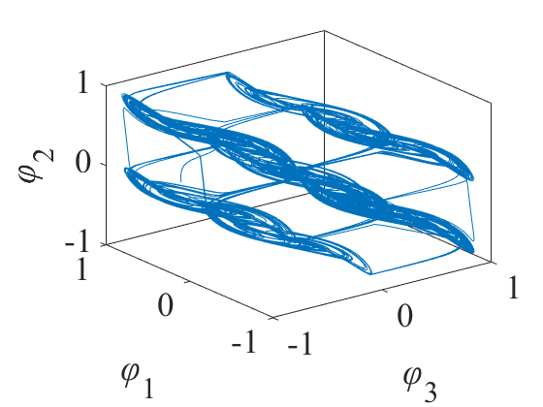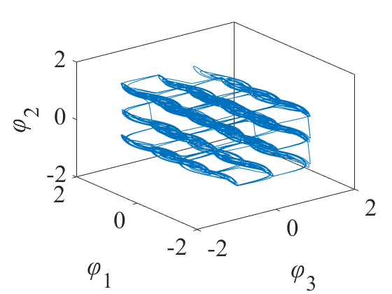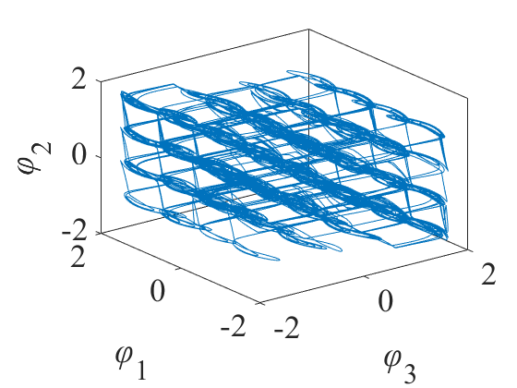

(a) (b) (c)

Fig. 11. Spatial multi-double-scroll chaotic attractors in the *φ*1-*φ*2-*φ*3 plane with different values of *N*1/*M*1, *N*2/*M*2 and *N*3/*M*3, (a) 2×2×2-double-scroll attractor (*M*1=0, *M*2=0, *M*3=0), (b) 3×3×3-double-scroll attractor (*N*1=1, *N*2=1, *N*3=1), (c) 4×4×4-double-scroll attractor (*M*1=1, *M*2=1, *M*3=1).



(a) (b) (c)

Fig. 12. Spatial multi-double-scroll chaotic attractors in the different planes with *N*1=*N*2=*N*3=1, (a) *φ*1*-φ*2, (b) *φ*1-*φ*3, (c) *φ*2-*φ*3.

Through numerical simulations, it was found that by varying the values of *Mi* or *Ni* (*i*=1, 2, 3), the spatial multi-double-scroll attractors in the form of [(2*N*1+1) or (2*M*1+2)] × [(2*N*2+1) or (2*M*2+2)] × [(2*N*3+1) or (2*M*3+2)] can be obtained. On the other hand, the spatial multi-scroll chaotic attractors exhibit the grid multi-scroll attractors on different planes. Taking *N*1=*N*2=*N*3=1 as an example, Fig. 12 shows 3×3 grid multi-scroll attractors on different planes.

**3.3. Spatial initial-offset coexisting attractors**

The initial value-related coexistence behavior is an important dynamic phenomenon in neural networks, which reflects the complexity and nonlinearity of neural network. In this section, keeping the parameters *a*=1, *b*=-0.001, *c*1=-0.0002, *c*2=4, *c*3=-1.4, *d*1=1.1, *e*1=1.62, *d*2=1.04, *e*2=1.71, *d*3=1.2, *e*3=2.62 unchanged, we investigated the initial value-related coexistence behavior through the bifurcation diagrams and the phase portraits using the above triple memristive HNN as an example. In the case of *N*1=*N*2=*N*3=2, we first plotted the bifurcation diagram of the state variable *φ*1 by varying the initial state *φ*10 in the range [-5, 5], with (*x*0, *y*0, *z*0, *φ*10, *φ*20, *φ*30) = (-1.2, 0.1, 0.1, *φ*10, 0.2, -1). As shown in Fig. 13(a), the diagram exhibits the multiple rectangular regions with a staircase-like pattern between them. Each rectangular region corresponds to a double-scroll chaotic attractor, and the position of these double-scroll chaotic attractors is determined by the value of the initial state *φ*10.

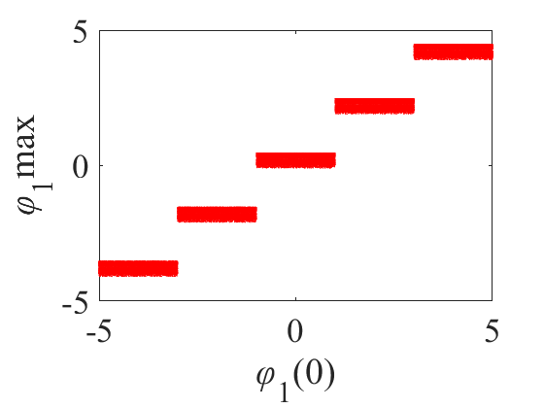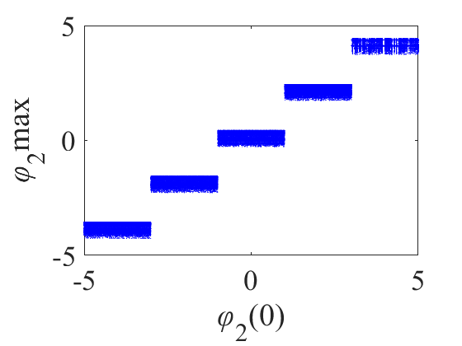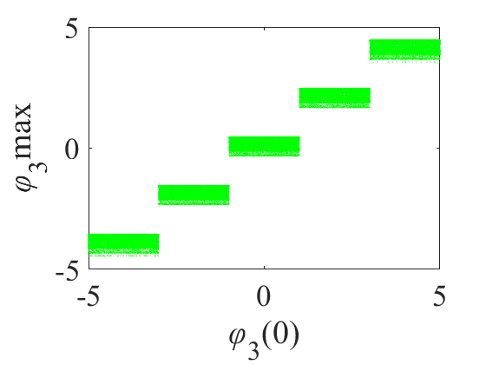

(a) (b) (c)

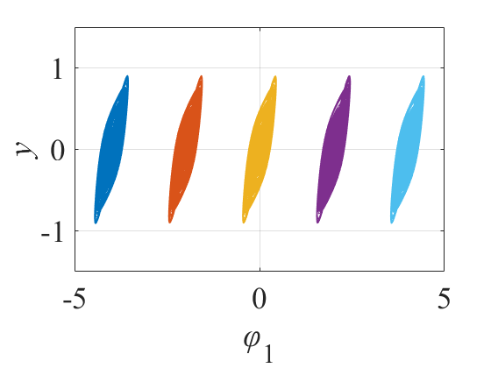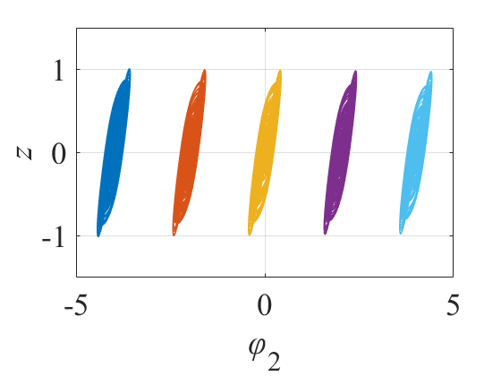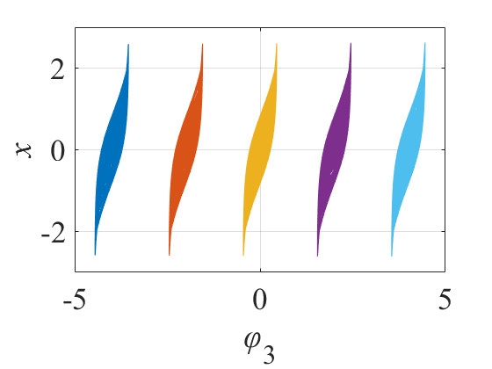

(d) (e) (f)

Fig. 13. Bifurcation diagrams with respect to the initial condition, (a) *φ*10 of [−5, 5], (b) *φ*20 of [−5, 5], (c) *φ*30 of [−5, 5]; the coexisting attractors in three different directions, (d) *φ*10=0, ±2, ±4, (e) *φ*20=0, ±2, ±4, (f) *φ*30=0, ±2, ±4.

Next, using the same parameters mentioned above, and the initial states (*x*0, *y*0, *z*0, *φ*10, *φ*20, *φ*30) are selected (-1.2, 0.1, 0.1, 0.1, *φ*20, -1) and (-1.2, 0.1, 0.1, 0.1, 0.2, *φ*30) respectively, we varied the initial states *φ*20 and *φ*30 in the range [-5, 5] and plotted the bifurcation diagrams of the state variables *φ*2 and *φ*3, respectively. These diagrams are shown in Fig. 13(b) and (c), respectively. According to the three bifurcation diagrams, it can be observed that the initial states *φ*10, *φ*20 and *φ*30 determine the positions of the chaotic attractors. The phase portraits drawn based on the above parameter conditions on the planes *φ*1-*y*, *φ*2-*z* and *φ*3-*x* are shown in Fig. 13(d), (e) and (f). As shown in Fig. 13(d), when the initial value *φ*10 takes the values of 0, ±2, and ±4, the five coexisting chaotic attractors are generated along the direction of *φ*1. These attractors have the same structure but the different positions, and the attractors at different positions correspond to the bar positions in the bifurcation diagram shown in Fig. 13(a). Meanwhile, the phase portraits in the *φ*2 and *φ*3 directions are given in Fig. 13(e) and (f) respectively, when the initial value *φ*20 and *φ*30 with 0, ±2, and ±4 are used as the initial states, showing the five coexisting chaotic attractors with the same structure and corresponding to Fig. 13(b) and (c), respectively. This indicates that the proposed triple memristive HNN model can generate the initial-value dependent coexisting behaviors in all three directions of *φ*1, *φ*2 and *φ*3.

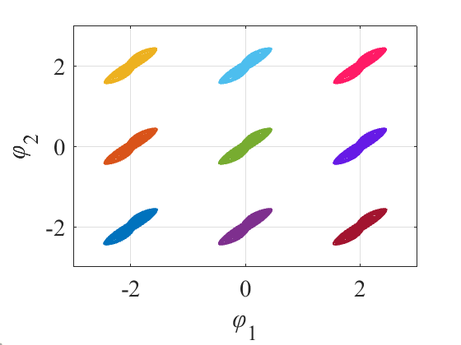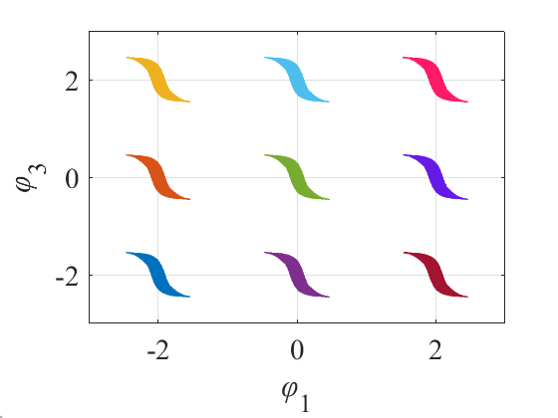

(a) (b)

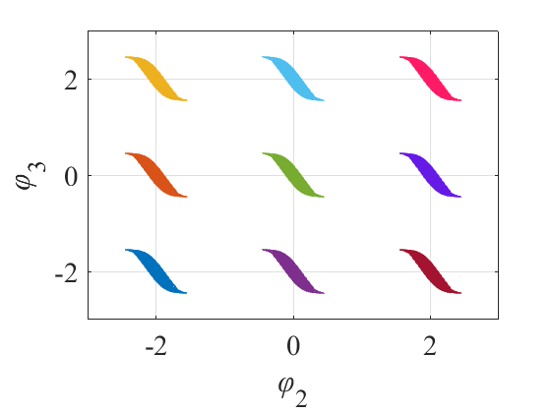 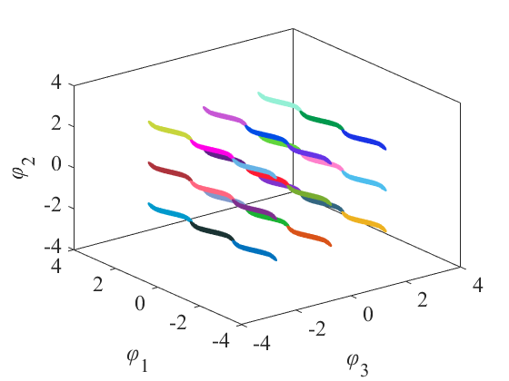

(c) (d)

Fig. 14. The spatial initial-offset coexisting attractors in three different planes: (a) (*φ*10, *φ*20) = (±2/0, ±2/0), (b) (*φ*10, *φ*30)=(±2/0, ±2/0), (c) (*φ*20, *φ*30)=(±2/0, ±2/0), (d) (*φ*10, *φ*20, *φ*30) = (±2/0, ±2/0, ±2/0).

At the same time, by selecting the parameters *N*1=*N*2=*N*3=1 and setting the initial state as (*φ*10, *φ*20) = (±2/0, ±2/0), the proposed triple memristive HNN model produces nine coexisting chaotic attractors in the *φ*1-*φ*2 plane, as shown in Fig. 14(a). Using the same approach, the coexisting chaotic attractors are obtained in the *φ*1-*φ*3 and *φ*2-*φ*3 planes by setting the initial states as (*φ*10, *φ*30) = (±2/0, ±2/0) and (*φ*20, *φ*30) = (±2/0, ±2/0) respectively, as depicted in Fig. 14(b) and (c). This reveals that the triple memristive HNN’s initial-offset coexisting behaviors can occur respectively in the *φ*1-*φ*2, *φ*1-*φ*3 and *φ*2-*φ*3 planes. Meanwhile, by selecting the initial state as (*φ*10, *φ*20, *φ*30) = (±2/0, ±2/0, ±2/0) while keeping the other parameters unchanged, the system exhibits twenty-seven coexisting chaotic attractors in the *φ*1-*φ*2-*φ*3 phase space, as shown in Fig. 14(d). Moreover, by changing the values of *M*i/*N*i (*i*=1, 2, 3) and adjusting the initial states of the memristors, the positions and quantities of the attractors can be changed respectively. The proposed triple memristive HNN model can simultaneously generate the coexisting chaotic attractors along the *φ*1, *φ*2 and *φ*3 three directions. These results confirm that the triple memristive HNN model can exhibit the spatial initial-offset coexisting behaviors.

**4. FPGA-based implementation**

The theoretical analysis and simulation result of the proposed HNN model usually need to be verified by the hardware implementation. Due to the hyperbolic tangent nonlinearity, the hardware implementation of the HNN model using an analog circuit is extremely complex. Additionally, the spatial initial-offset coexisting behaviors generated by the HNN model are highly dependent on the initial states, but the initial states can not be pre-set in the analog circuit. However, the digital circuits based on FPGA (Field Programmable Gate Array) can use the advantages of adders and multipliers, exponential calculators and comparators to precisely control the initial state and time step through software [43]. Therefore, this section chooses the FPGA platform to verify the simulation results of the proposed HNN model.

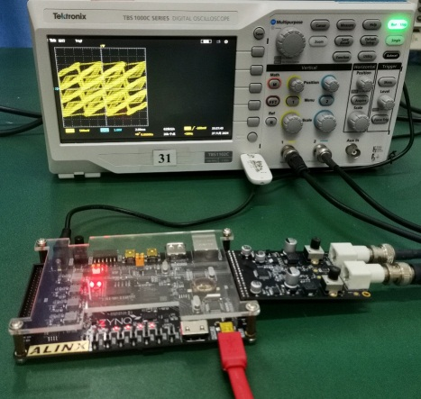

Fig. 15. Experimental setup of FPGA hardware platform connected to a digital oscilloscope.

In this section, we utilize the Vivado 2018.3 platform to synthesize the proposed HNN model with the variable number memristive self-connected synapses based on FPGA. First, the proposed continuous-time HNN model was discretized using the high-order Runge-Kutta algorithm. The discrete-time module was programmed using the Verilog Hardware Description Language (VHDL) and implemented on the Xilinx ZYNQ-XC7Z020 board. The discrete time step was set to 0.001. The floating-point calculations were used to obtain the experimental results which are consistented with the simulation results. To accommodate the limitations of the FPGA Xilinx ZYNQ-XC7Z020 board, the floating-point numbers were converted to the 14-bit fixed-point numbers for output.

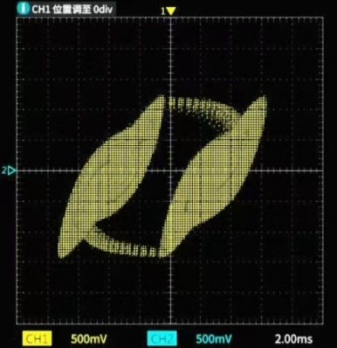 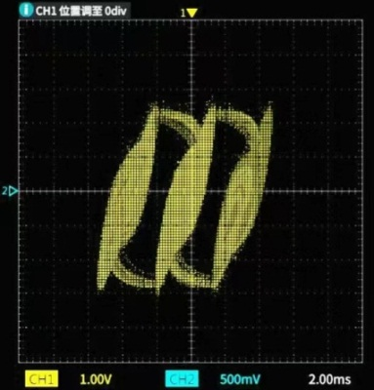 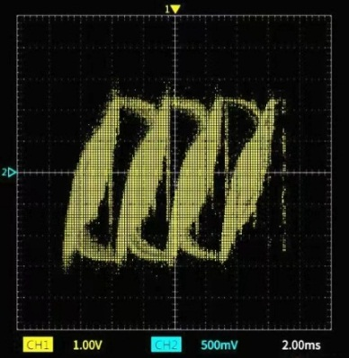

(a) (b) (c)

Fig. 16. The experimental results of single direction multi-scroll attractors in the *φ*1-*y* plane with the different values of *N* and *M*, (a) *M*=0, (b) *N*=1, (c) *M*=1.

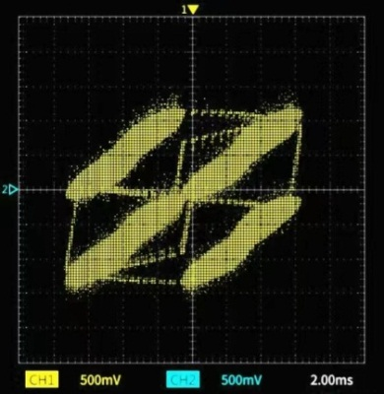 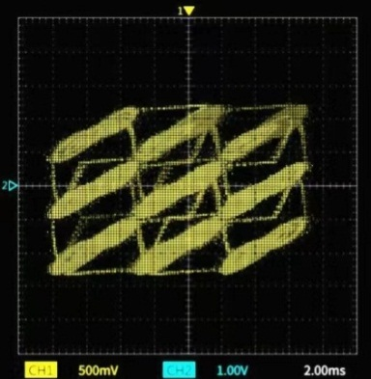 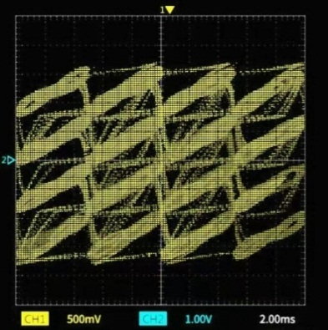

(a) (b) (c)

Fig. 17. The experimental results of the controllable number of grid multi-scroll chaotic attractors in the *φ*1-*φ*2 plane, (a) 2×2-double-scroll attractor, (b) 3×3-double-scroll attractor, (c) 4×4-double-scroll attractor.

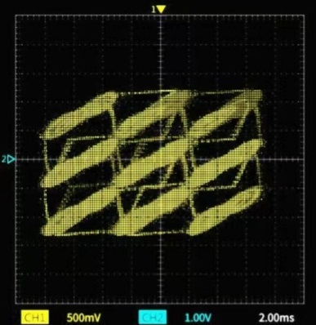 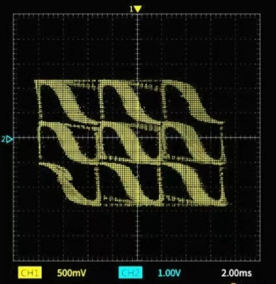 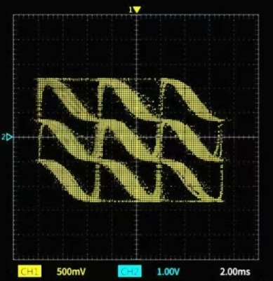

(a) (b) (c)

Fig. 18. The experimental results of spatial multi-double-scroll 3×3×3 attractors on FPGA in various plane projections, (a) *φ*1*-φ*2, (b) *φ*1-*φ*3, (c) *φ*2-*φ*3.

Fig. 15 shows the experimental setup of the FPGA hardware platform connected to a digital oscilloscope. The bitstream files generated on the workstation were integrated into the FPGA development board, and the dual channel DAC unit can select the output signals of x0_4 and x0_5, or x0_4 and x0_6, or x0_5 and x0_6. Fig. 16 shows the experimental results of single direction multi-scroll attractors in the *φ*1-*y* plane with the different values of *N* and *M*, which is consistented with the simulation results as shown in Fig. 5(b), (c) and (d). The controllable number of grid multi-scroll chaotic attractors in the *φ*1-*φ*2 plane can be observed as shown in Fig. 17, which is consistented with the simulation results as shown in Fig. 8(a), (b) and (c). The spatial multi-scroll attractors projectioned on different planes can be observed on the oscilloscope, as shown in Fig. 18, which is consistented with the simulation results as shown in Fig. 12(a), (b) and (c). Furthermore, the coexistence of double-scroll attractors associated with the spatial initial-offset behavior is presented in Fig. 19, which is consistented with the simulation results as shown in Fig. 14(b). It can be found that the FPGA realization matches exactly with the MATLAB platform, which demonstrates the correctness and feasibility of these multi-scroll attractors across the different type of platforms. Besides, the performance comparison of the proposed multi-direction multi-scroll HNN model with the existing memristor-based neural network is listed in Table 1, which includes scroll type, scroll number, coexisting attractor type, multi-direction coexisting attractor and hardware implementation.

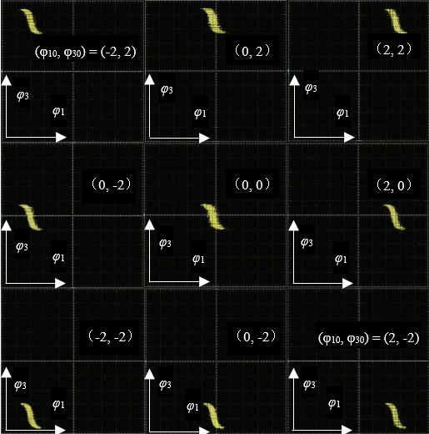

Fig. 19.The experimental results of the spatial initial-offset coexisting attractors on *φ*1*-φ*3 plane, as (*φ*10, *φ*30) = (±2/0, ±2/0).

Table 1. Comparison between this work and the existing memristor-based neural network.

|  |  |  |  |  |  |
| --- | --- | --- | --- | --- | --- |
| Reference | Scroll type | Scroll number | Coexisting attractor type | Multi-direction  coexisting attractor | Hardware implementation |
| [20] | Double-scroll | Two | Coexisting double-scroll | No | No |
| [26] | Single-scroll | One | Coexisting one-scroll | No | Yes |
| [34] | Single direction multi-scroll | Infinite | Coexisting one-scroll | No | Yes |
| [37] | Grid  multi-double-scroll | Infinite | Coexisting double-scroll | No | Yes |
| This work | Single direction, grid and spatial multi-double-scroll | Infinite | Coexisting multi-double-scroll | Yes | Yes |

**5. Conclusion**

In this paper, a new method for generating multi-scroll chaotic attractors in HNN with the variable number memristive self-connected synapses is designed. Firstly, the single memristive HNN model is constructed by introducing a multi-piecewise memristor to simulate the self-connected synapse of neuron 2, which can realize the expansion of the multi-scroll attractors in single direction. Secondly, by further introducing the multi-piecewise memristors to simulate the other self-connected synapses of neuron 3 and neuron 1, the double memristive HNN model and the triple memristive HNN model have been constructed, which can realize the grid and spatial multi-scroll attractors respectively. Numerical simulations show that the proposed HNN models can increase the expansion directions of multi-scroll attractors by increasing the number of memristors, and also can generate the spatial initial-offset coexisting attractors by changing the memristor’ initial states. Finally, the experimental results conducted on the FPGA platform successfully confirm the multi-scroll attractors and the spatial initial-offset behavior. In conclusion, these findings provide a valuable insight into the generation mechanism of multi-direction multi-scroll chaotic attractors. However, how to apply these multi-direction multi-scroll chaotic attractors to pseudorandom number generator and image encryption needs further research.

**CRediT authorship contribution statement**

**Qiuzhen Wan**: Conceptualization, Validation, Supervision, Writing, Resources, Funding acquisition. **Qiao Yang**: Investigation, Methodology, Data curation, Writing. **Tieqiao Liu**: Investigation, Software, Visualization. **Chaoyue Chen**: Investigation, Software. **Kun Shen**: Methodology, Software.

**Declaration of competing interest**

The authors declare that they have no known competing financial interests or personal relationships that could have appeared to influence the work reported in this paper.

**Data availability**

Data will be made available on request.

**Acknowledgement**

The authors would like to thank the project supported by the National Natural Science Foundation of China under Grants 61901169 and 61804037, and the Natural Science Foundation of Hunan Province under Grant 2024JJ5267.

**References**

1. Zainab Aram, Sajad Jafari, Jun Ma, Julien C. Sprott, Sareh Zendehrouh, Viet-Thanh Pham. Using chaotic artificial neural networks to model memory in the brain. Communications in Nonlinear Science and Numerical Simulation, 2017, 44: 449-459.
2. W. de Haan, W. M. van der Flier, T. Koene, L. L. Smits, P. Scheltens, C. J. Stam. Disrupted modular brain dynamics reflect cognitive dysfunction in Alzheimer’s disease. Neuroimage, 2012, 59(4): 3085-3093.
3. Junwei Sun, Yangyang Wang, Peng Liu, Shiping Wen, Yanfeng Wang. Memristor-based neural network circuit with multimode generalization and differentiation on pavlov associative memory. IEEE Transactions on Cybernetics 2023, 53(5): 3351-3362.
4. Qiuzhen Wan, Jiong Liu, Peng Qin, Kunliang Sun, Qinghui Hong. The design of self-healing memristive network circuit based on VTA DA neurons and its application. Neurocomputing, 2024, 575: 127283.
5. Quanli Deng, Chunhua Wang, Jingru Sun, Yichuang Sun, Jinguang Jiang, Hairong Lin, Zekun Deng. Nonvolatile CMOS memristor, reconfigurable array, and its application in power load forecasting. IEEE Transactions on Industrial Informatics, 2024, 20(4): 6130-6141.
6. Qiuzhen Wan, Jiong Liu, Tieqiao Liu, Kunliang Sun, Peng Qin. Memristor-based circuit design of episodic memory neural network and its application in hurricane category prediction. Neural Networks, 2024, 174(6): 106268.
7. Xiaoyu Hu, Chongxin Liu. Dynamic property analysis and circuit implementation of simplified memristive Hodgkin-Huxley neuron model. Nonlinear Dynamics, 2019, 97(2): 1721-1733.
8. Ying Xie, Zhao Yao, Guodong Ren, Jun Ma. Estimate physical reliability in Hindmarsh-Rose neuron. Physics Letters A, 2023, 464: 128693.
9. Giorgia Dellaferrera, Stanisław Woźniak, Giacomo Indiveri, Angeliki Pantazi, Evangelos Eleftheriou. Introducing principles of synaptic integration in the optimization of deep neural networks. Nature Communications, 2022, 13(1): 1885.
10. Peng Yao, Huaqiang Wu, Bin Gao, Jianshi Tang, Qingtian Zhang, Wenqiang Zhang, J Joshua Yang, He Qian. Fully hardware-implemented memristor convolutional neural network. Nature, 2020, 577: 641-646.
11. Lilian Huang, Yue Zhang, Jianhong Xiang, Jin Liu. Extreme multistability in a Hopfield neural network based on two biological neuronal systems. IEEE Transactions on Circuits and Systems II: Express Briefs, 2022, 69(11): 4568-4572.
12. Maheshwar Pd. Sah, Hyongsuk Kim, Leon O. Chua. Brains are made of memristors. IEEE Circuits and Systems Magazine, 2014, 14(1): 12-36.
13. Sen Zhang, Chunbiao Li, Jiahao Zheng, Xiaoping Wang, Zhigang Zeng, Guanrong Chen. Generating any number of diversified hidden attractors via memristor coupling. IEEE Transactions on Circuits and Systems I: Regular Papers, 2021, 68(12): 4945-4956.
14. Qiuzhen Wan, Fei Li, Zidie Yan, Simiao Chen, Jiong Liu, Wenkui Ji, Fei Yu. Dynamic analysis and circuit realization of a novel variable-wing 5D memristive hyperchaotic system with line equilibrium. European Physical Journal-Special Topics, 2022, 231: 3029-3041.
15. Qiang Lai, Liang Yang, Guanrong Chen. Design and performance analysis of discrete memristive hyperchaotic systems with stuffed cube attractors and ultraboosting behaviors. IEEE Transactions on Industrial Electronics, 2024, 71(7): 7819-7828.
16. Bocheng Bao, Hui Qian, Quan Xu, Mo Chen, Jiang Wang, Yajuan Yu. Coexisting behaviors of asymmetric attractors in hyperbolic-type memristor based Hopfield neural network. Frontiers in Computational Neuroscience, 2017, 11(8): 81.
17. Fei Yu, Xinxin Kong, Wei Yao, Jin Zhang, Shuo Cai, Hairong Lin, Jie Jin. Dynamics analysis, synchronization and FPGA implementation of multiscroll Hopfield neural networks with non-polynomial memristor. Chaos, Solitons and Fractals, 2024, 179: 114440.
18. Minglin Ma, Yaping Lu. Synchronization in scale-free neural networks under electromagnetic radiation. Chaos: An Interdisciplinary Journal of Nonlinear Science, 2024, 34: 033116.
19. Xinlei An, Li Xiong, Qianqian Shi, Shuai Qiao, Li Zhang. Dynamics explore of an improved HR neuron model under electromagnetic radiation and its applications. Nonlinear Dynamics, 2023, 111(10): 9509-9535.
20. Chunhua Wang, Junhui Liang, Quanli Deng. Dynamics of heterogeneous Hopfield neural network with adaptive activation function based on memristor. Neural Networks, 2024, 178: 106408.
21. Xiaoyu Hu, Chongxin Liu, Ling Liu, Junkang Ni, Yapeng Yao. Chaotic dynamics in a neural network under electromagnetic radiation. Nonlinear Dynamics, 2018, 91(3): 1541-1554.
22. Hairong Lin, Chunhua Wang. Influences of electromagnetic radiation distribution on chaotic dynamics of a neural network. Applied Mathematics and Computation, 2020, 369(1): 124840.
23. Qiang Lai, Liang Yang. Discrete memristor applied to construct neural networks with homogeneous and heterogeneous coexisting attractors. Chaos, Solitons and Fractals, 2023, 174: 113807.
24. Chengjie Chen, Fuhong Min, Yunzhen Zhang, Bocheng Bao. Memristive electromagnetic induction effects on Hopfield neural network. Nonlinear Dynamics, 2021, 106: 2559-2576.
25. Han Bao, Dong Zhu, Wenbo Liu, Quan Xu, Mo Chen, Bocheng Bao. Memristor synapse-based Morris-Lecar model: bifurcation analyses and FPGA-based validations for periodic and chaotic bursting/spiking firings. International Journal of Bifurcation and Chaos, 2020, 30(3): 2050045.
26. Qiuzhen Wan, Zidie Yan, Fei Li, Simiao Chen, Jiong Liu. Complex dynamics in a Hopfield neural network under electromagnetic induction and electromagnetic radiation. Chaos: An Interdisciplinary Journal of Nonlinear Science, 2022, 32(7): 073107.
27. Bocheng Bao, Zhuowu Wang, Zhongyun Hua, Mo Chen, Han Bao. Regime transition and multi-scroll hyperchaos in a discrete neuron model. Nonlinear Dynamics, 2023, 111: 13499-13512.
28. Qiang Lai, Zhiqiang Wan, Hui Zhang, Guanrong Chen. Design and analysis of multiscroll memristive Hopfield neural network with adjustable memductance and application to image encryption. IEEE Transactions on Neural Networks and Learning Systems, 2023, 34(10): 7824-7837.
29. Quanli Deng, Chunhua Wang, Hairong Lin. Chaotic dynamical system of Hopfield neural network influenced by neuron activation threshold and its image encryption. Nonlinear Dynamics, 2024, 112: 6629-6646.
30. Ning Wang, Guoshan Zhang, Houzhen Li. Parametric control for multi-scroll attractor generation via nested sine-PWL function. IEEE Transactions on Circuits and Systems II: Express Briefs, 2021, 68(3): 1033-1037.
31. Yan Yang, Lilian Huang, Nikolay V. Kuznetsov, Qiang Lai. Design and implementation of grid-wing hidden chaotic attractors with only stable equilibria. IEEE Transactions on Circuits and Systems I: Regular Papers, 2023, 70(12): 5408-5420.
32. Dengwei Yan, Musha Ji’e, Lidan Wang, Shukai Duan, Xinyu Du. Generating novel multi-scroll chaotic attractors via fractal transformation. Nonlinear Dynamics, 2022, 107(4): 3919-3944.
33. Nabil Ben Slimane, Kais Bouallegue, Mohsen Machhout. Designing a multi-scroll chaotic system by operating logistic map with fractal process. Nonlinear Dynamics, 2017, 88(34): 1655-16754.
34. Sen Zhang, Jia Hao Zheng, Xiaoping Wang, Zhigang Zeng. Multi-scroll hidden attractor in memristive HR neuron model under electromagnetic radiation and its applications. Chaos: An Interdisciplinary Journal of Nonlinear Science, 2021, 31(1): 011101.
35. Fei Yu, Xinxin Kong, Abdulmajeed Abdullah Mohammed Mokbel, Wei Yao, Shuo Cai. Complex dynamics, hardware implementation and image encryption application of multiscroll memeristive hopfield neural network with a novel local active memeristor. IEEE Transactions on Circuits and Systems-II: Express Briefs, 2023, 70(1): 326-330.
36. Qiuzhen Wan, Fei Li, Simiao Chen, Qiao Yang. Symmetric multi-scroll attractors in magnetized Hopfield neural network under pulse controlled memristor and pulse current stimulation. Chaos, Solitons and Fractals, 2023, 169(4): 113259.
37. Qiang Lai, Zhiqiang Wan, Paul Didier Kamdem Kuate. Generating grid multi-scroll attractors in memristive neural networks. IEEE Transactions on Circuits and Systems I: Regular Papers, 2023, 70(3): 1324-1336.
38. Qiuzhen Wan, Simiao Chen, Qiao Yang, Jiong Liu, Kunliang Sun. Grid multi-scroll attractors in memristive Hopfield neural network under pulse current stimulation stimulation and multi-piecewise memristor. Nonlinear Dynamics, 2023, 111: 18505-18521.
39. J. L. Echenausía-Monroy, S. Jafari, G. Huerta-Cuellar, H. E. Gilardi-Velázquez. Predicting the emergence of multistability in a monoparametric PWL system. International Journal of Bifurcation and Chaos, 2022, 32(14): 2250206.
40. Hairong Lin, Chunhua Wang, Cong Xu, Xin Zhang, Herbert H. C. Iu. A memristive synapse control method to generate diversified multi-structure chaotic attractors. IEEE Transactions on Computer-Aided Design of Integrated Circuits and Systems, 2023, 42(3): 942-955.
41. Han Bao, Mengjie Hua, Jun Ma, Mo Chen, Bocheng Bao. Offset-control plane coexisting behaviors in two-memristor-based Hopfield neural network. IEEE Transactions on Industrial Electronics, 2023, 70(10): 10526-10535.
42. Christopher P. Silva. Shil’nikov’s theorem-a tutorial. IEEE Transactions on Circuits and Systems I: Fundamental Theory and Applications, 1993, 40(10): 675-682.
43. Sara M. Mohamed, Wafaa S. Sayed, Ahmed G. Radwan, Lobna A. Said. FPGA implementation of reconfigurable CORDIC algorithm and a memristive chaotic system with transcendental nonlinearities. IEEE Transactions on Circuits and Systems I: Regular Papers, 2022, 69(7): 2885-2892.

**Highlights**

* The HNN models with variable number memristive self-connected synapse are proposed.
* This paper can generate single direction, grid and spatial multi-scroll attractors.
* The spatial initial-offset coexisting attractors are explored in detail.
* The feasibility of the proposed HNN models is verified by the FPGA platform.